BRACT’s
Vishwakarma Institute of Technology, Pune
Practical Implementation Sheet
Department: CSE-AI Semester: 5 Academic Year: 2026-27
Division: E Batch: 1 Practical No: 1
Roll no: 42 PRN No: 12414728 Name of Student: Saachi Laturiya
Subject Name : Deep Learning

Problem Statement : Install and configure TensorFlow/Keras in Google Colab. Load the KMNIST dataset, perform data preprocessing, normalization, train-test split verification, and visualize sample images.
Algorithm :
- Open Google Colab and install the required Python packages.
- Import TensorFlow, NumPy, Matplotlib, and the KMNIST dataset.
- Load the KMNIST dataset into training and testing sets.
- Display the dimensions and basic information of the dataset.
- Visualize a sample KMNIST image.
- Display multiple sample images for dataset exploration.
- Convert image data type from uint8 to float32.
- Normalize pixel values from 0–255 to 0–1.
- Verify the normalization by checking the minimum and maximum pixel values.
- Display a normalized sample image.
- Verify the training and testing sample distribution.
Code :
1. Import the required libraries for deep learning, numerical computation, visualization, and loading the KMNIST dataset.
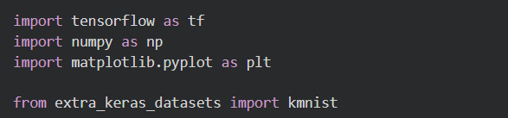
2. Load the KMNIST dataset into training and testing sets.
3. Display the dimensions of the training and testing datasets.
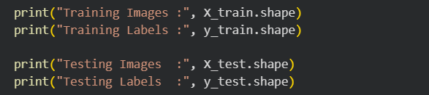
4. Display the image size, number of classes, and pixel value range of the dataset.
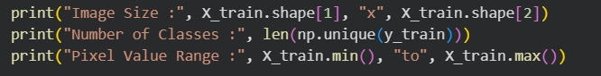
5. Visualize a sample KMNIST image from the training dataset.
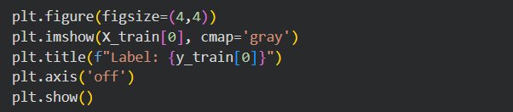
6. Display multiple sample images to understand the dataset distribution.
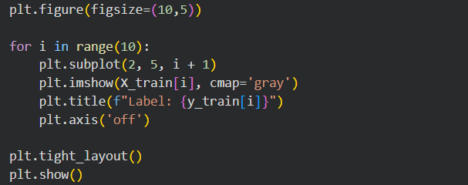
7. Convert the image data type from uint8 to float32 for preprocessing.
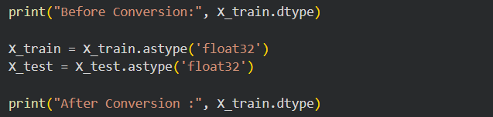
8. Normalize the pixel values from the range 0–255 to 0–1.
Verify that the pixel values have been normalized successfully.
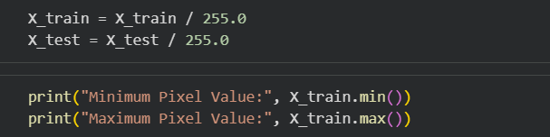
9. Display a normalized sample KMNIST image after preprocessing.
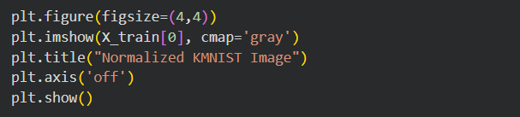
Output :
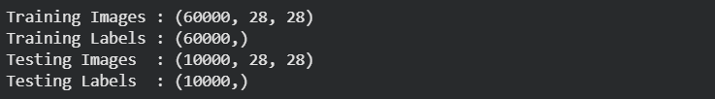
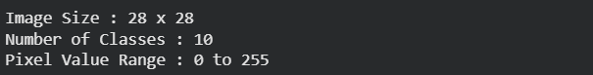
Figure 1: Sample KMNIST character image from the training dataset.
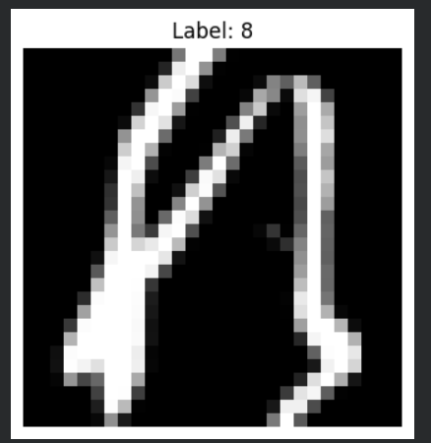
Figure 2: Visualization of the first ten sample KMNIST characters from the training dataset.
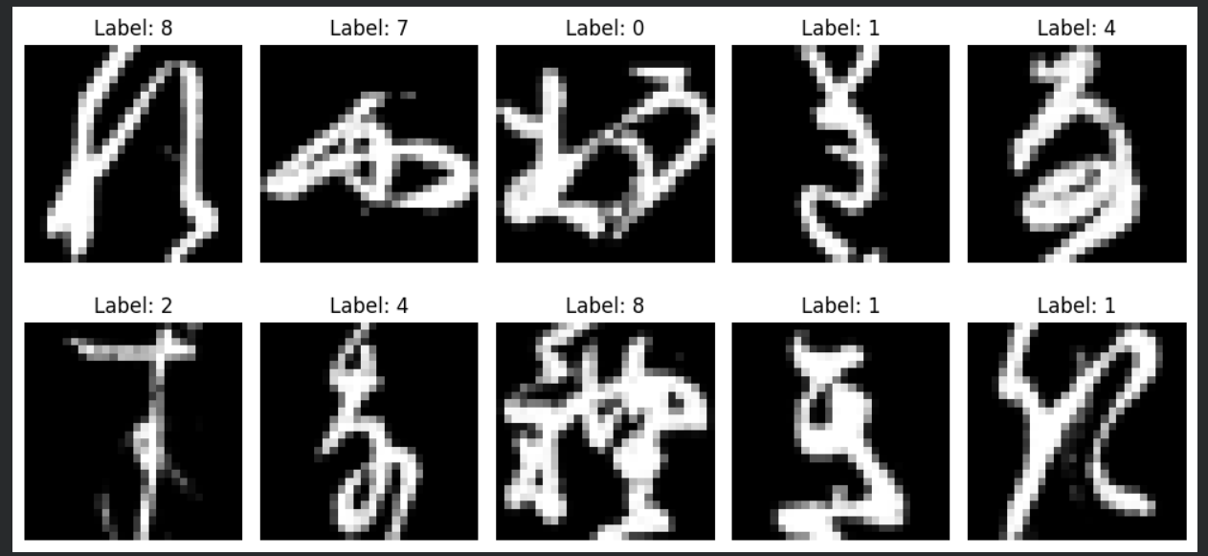
Figure 3: Normalized sample KMNIST character after preprocessing.
